**Operating System - Assignment - 3**

***Q.1 Local Area Networks utilize a media access method called CSMA/CD, in which stations sharing a bus can sense the medium and detect transmissions as well as collisions. In the Ethernet protocol, stations requesting the shared channel do not transmit frames if they sense the medium is busy. When such transmission has terminated, waiting stations each transmit their frames. Two frames that are transmitted at the same time will collide. If stations immediately and repeatedly retransmit after collision detection, they will continue to collide indefinitely.***

***(a) Is this a resource deadlock or a livelock?***

**Answer:** This is a competition synchronization anomaly. It is a livelock. We can say it is a scheduling livelock. It is not a resource livelock or deadlock, since stations are not holding resources that are requested by others and thus a circular chain of stations holding resources while requesting others does not exist.

***(b) Can you suggest a solution to this anomaly?***

**Answer:** It require that stations that detect a collision of their transmission must wait for some random number of time slots before retransmitting. The interval within which the time slot is chosen is variable after each successive collision, dynamically adjusting to heavy traffic loads.

***(c) Can starvation occur with this scenario?***

**Answer:** Because access to the channel is probabilistic, and because newly arriving stations can compete and be allocated the channel before stations that have retransmitted some number of times, starvation is possible.

***Q.2 Consider the following state of a system with four processes, P1, P2, P3, and P4, and five types of resources, RS1, RS2, RS3, RS4, and RS5:***

***Show that there is a deadlock in the system. Identify the processes that are deadlocked.?***

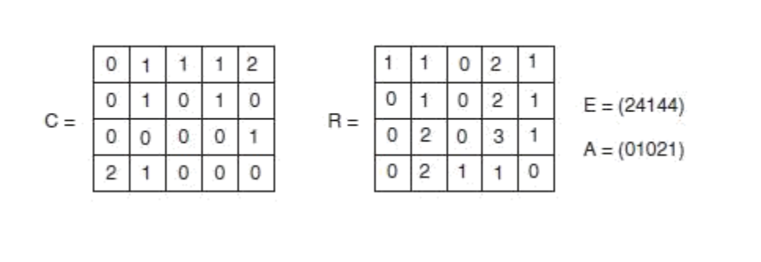

**Answer:**

First, the set of unmarked processes, P = (P1 P2 P3 P4)

R1 is not less than or equal to A

R2 is less than A; Mark P2; A = (0 2 0 3 1); P = (P1 P3 P4)

R1 is not less than or equal to A

R3 is equal to A; Mark P3; A = (0 2 0 3 2); P = (P1 P4)

R1 is not less than or equal to A

R4 is not less than or equal to A

So, processes P1 and P4 remain unmarked. As both are holding resources and can’t finish, They are deadlocked.

***Ques 3: In the below figure, If D asks for one more unit, does this lead to a safe state or an unsafe one? What if the request came from C instead of D? ( Note : Maximum units available is 10).***

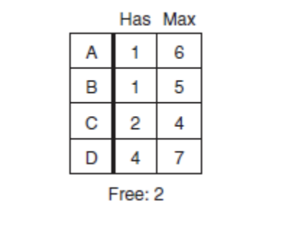

**Answer:**

If D is allotted one more unit then it will lead to unsafe state because D will further need 2 more to get it complete but only one will be left free and no other process will be able to complete i.e unsafe state!

If request comes from C, it will be in safe state as C will only need 1 more to complete and release resources and as one resource will be in free after C request, But if second request comes from other than C, it will lead to a deadlock situation!